Mainland of Pets

Technical Documentation

JuFeng Li

2019.11

目录

1.FOLLOWING 3

2.COMBAT 3

3.Backpack System 6

4.Map 8

5.UI 9

### 1.FOLLOWING

Determine the distance between the pet and the character. If the pet is too far away, it will approach the character twice as fast

If in attack mode, the pet will stop following and fight

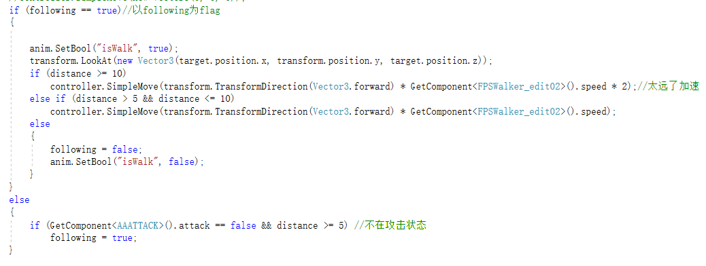

### 2.COMBAT

#### 2.1.AI of monster’s attack

##### The setting of the attack method

1.through launching attack props to achieve the mechanism，Attacks are judged by bullets. Creates animal attack effects on bullets

2.the monster’s patience ，When the player forces a pet in battle to follow, the monster will track the pet until the patience is gone. Default is 5 seconds

3.use different tags to differentiate the monsters, the pet following and the pets in bag. Monster's tag is “monster”, battle pet's tag is “pet”, backpack pet's tag is “bag”, and different tags execute different battle modes

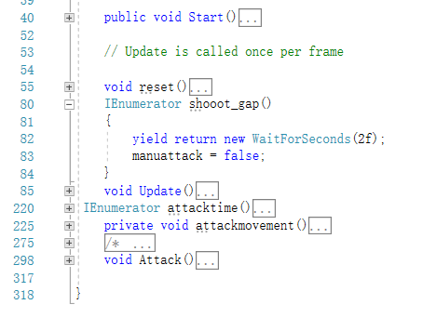

Main functions，

1. Two coroutines control manual attacks and automatic attacks

2. The reset function is used to reset the pet’s state and effectively prevent bugs

3.Update function incorporate most decisions

4.Attack function controls the launch of props, which come from the skills.

4.De-battle regeneration mechanism，The default health regeneration rate of pets and pack pets is 1%/s. In order to avoid players from switching pets to fight powerful monsters, the regeneration speed of monsters is 10%/s. At the same time, switching pets to monsters will immediately exit the battle

#### 2.2.The Attributes of the pets

1.Blood script gives various attributes, and some attributes are calculated by formulas

2. DBA script binds to the character and calls pet data on it

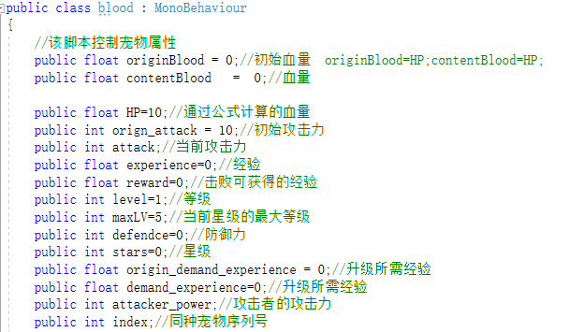

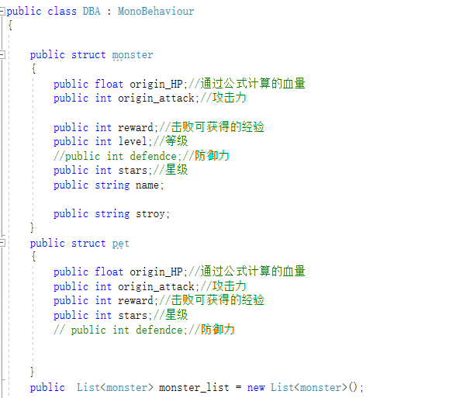

#### 2.3.Implementation of the Combat

Main functions，

1. Two coroutines control manual attacks and automatic attacks

2. The reset function is used to reset the pet’s state and effectively prevent bugs

3.Update function incorporate most decisions

4.Attack function controls the launch of props, which come from the skills.



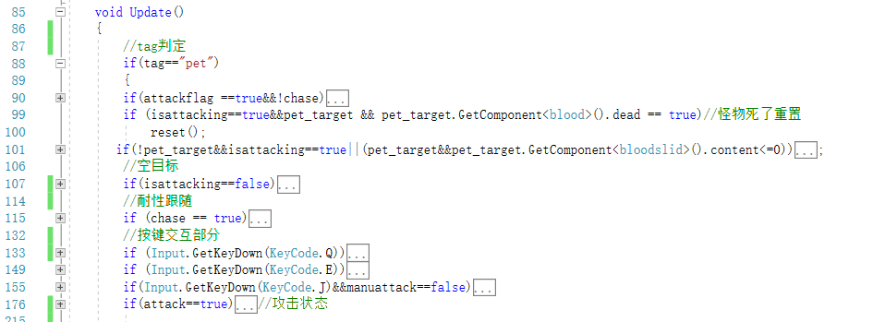

### 3.Backpack System

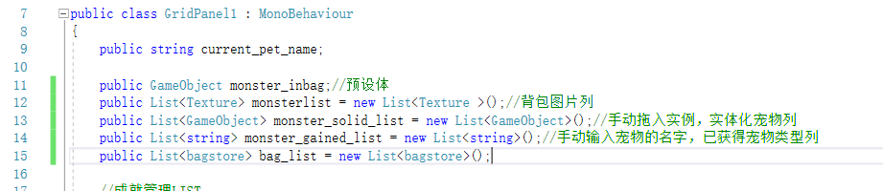1.bag

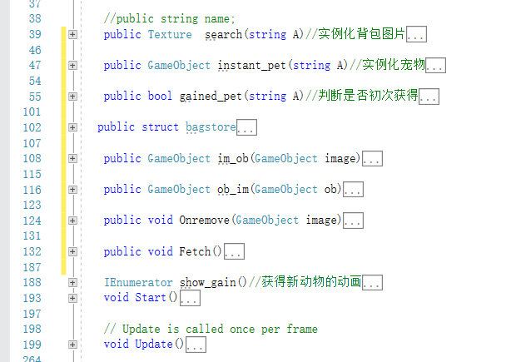

Judg whether the first time gaining a certain pet

The animation of gaining a new pet

The textures of pets

2.the codes of acquiring a pet

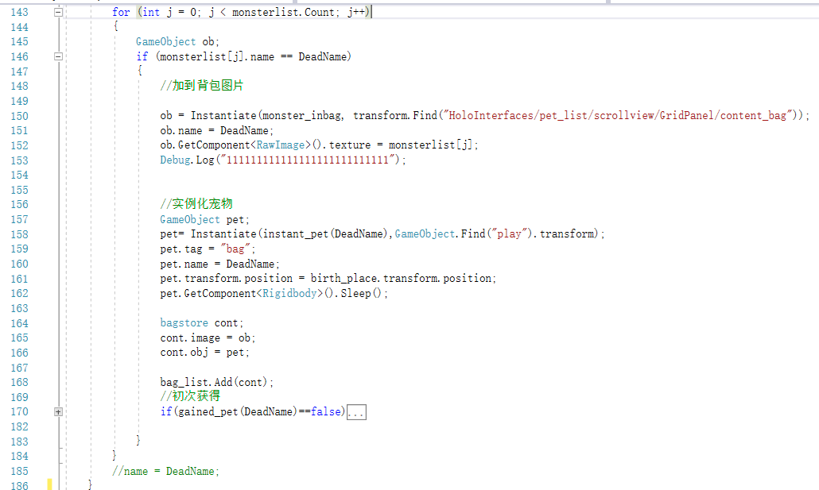

3.the codes of switch pets

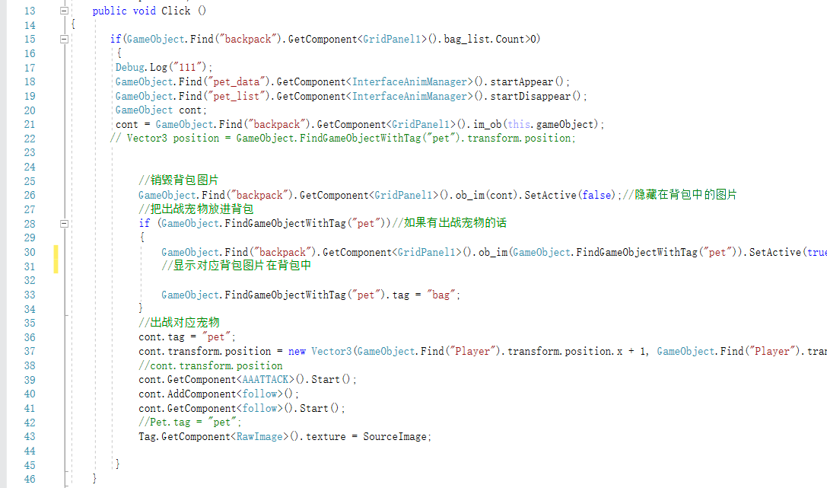

### 4.Map

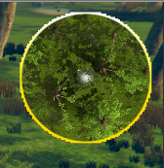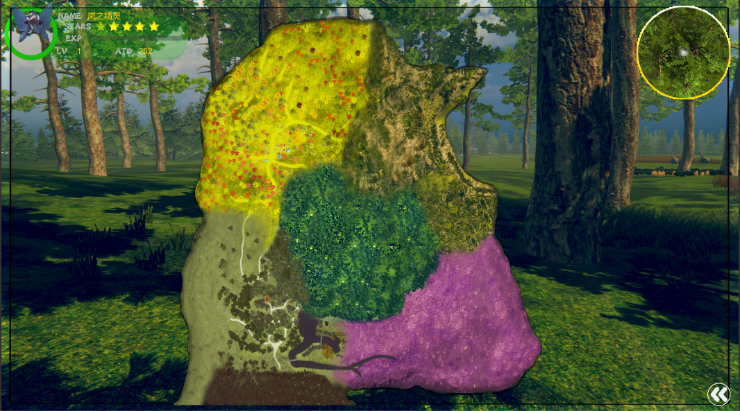

When players play freely in such a large map, there will be a problem of finding the path. At this time, the minimap will display the map's five sections as well as the coordinates and direction of the player, which will feedback the player's position information to the player in real time, greatly increasing the game experience, and no longer have to worry about losing the direction.

### 5.UI

